**Gurugram's Air Quality Index**

**Time Series Analysis**

**1- Data Description**

This dataset provides a comprehensive record of Gurugram's daily Air Quality Index (AQI), spanning from April 2023 to March 2024. It comprises three key columns: Date and AQI.

The objective is to analyse temporal patterns and trends in Gurugram's daily Air Quality Index (AQI) data from April 2023 to March 2024. By employing time series analysis and forecasting techniques, the aim is to uncover insights for environmental management and public health interventions, facilitating informed decision-making to mitigate air pollution and enhance air quality in Gurugram.

No. of rows: 397  
No. of columns: 2

The Data looks as follows:

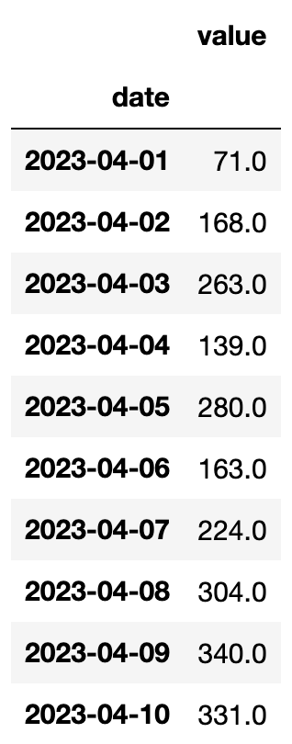

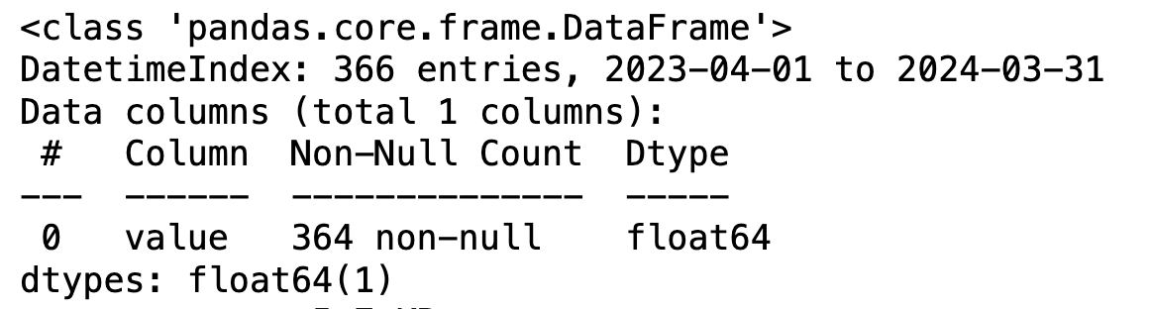

There were two null values in the dataset which has been filled with the linear interpolation

**2- Data Visualization and Interpretations**

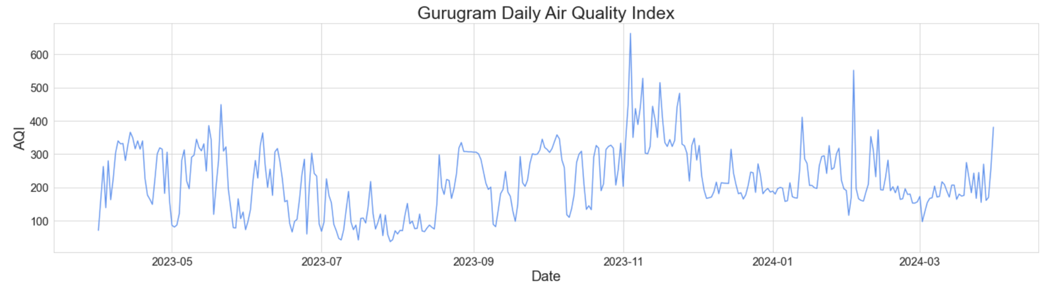

To transform the discrete data into a continuous format, two options are available:

1) **Log transformation:** This method not only converts the data into a continuous form but also scales it to a more manageable range.

2) **Adding a number between 0 and 1 from a uniform distribution:** This approach introduces randomness to the data while maintaining continuity, thereby ensuring a smooth transition from discrete to continuous representation.

**Log AQI Series plot:**

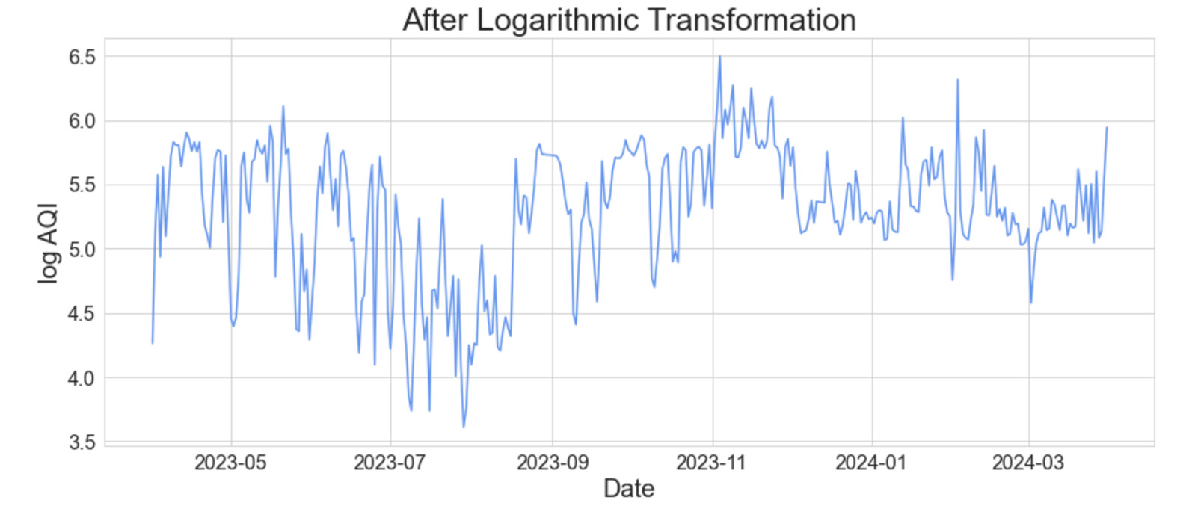

**AQI + U(0,1) Series plot:**

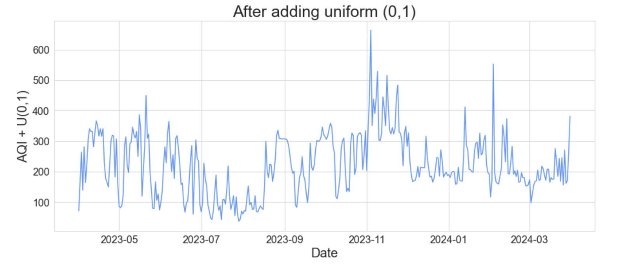

The log transformation has effectively compressed the range of the series, resulting in a more manageable and scaled representation of the data. The uniform transformed series appears to maintain its original characteristics, showing no discernible change.

The series plots reveal a dynamic pattern where the mean and variance exhibit fluctuations over time, indicating a departure from stationarity, which will be thoroughly examined in the next section.

To validate a time series model, the dataset is typically divided into two parts: one for training and another for testing. In this context, the Air Quality Index (AQI) data for the last 42 days is used for the testing set.

**3- Examining Stationarity**

**3.1- For Log transformed series**



**ACF Plot –**

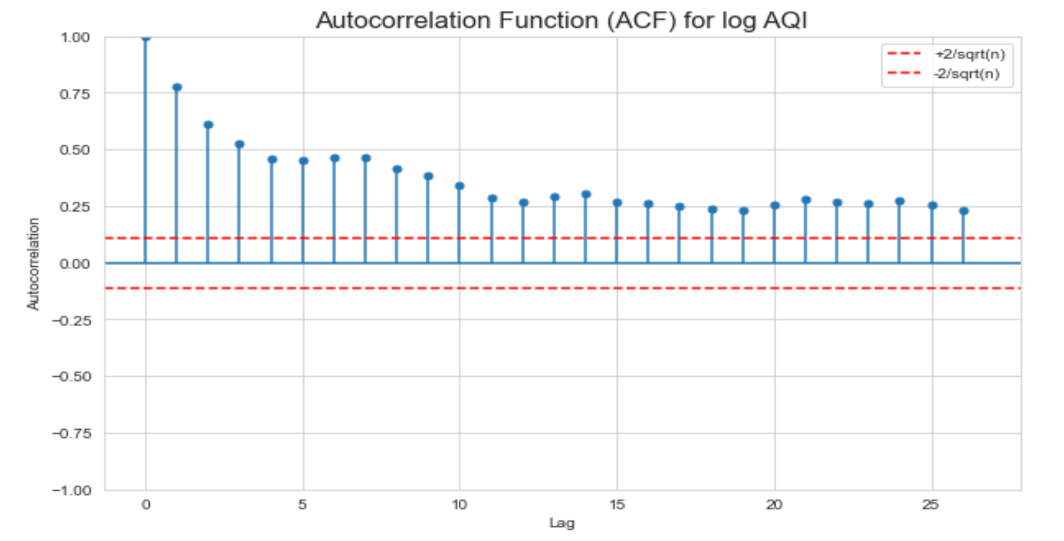

* The autocorrelation function (ACF) displays a slow decay, indicating the presence of a unit root and thus non-stationarity.
* Additionally, prominent spikes are evident at lags 7, 14, and 21, implying the existence of seasonality with a weekly period of 7 days. Addressing this seasonality will be a key focus during the identification of SARIMA models.

**Differencing to achieve stationarity**

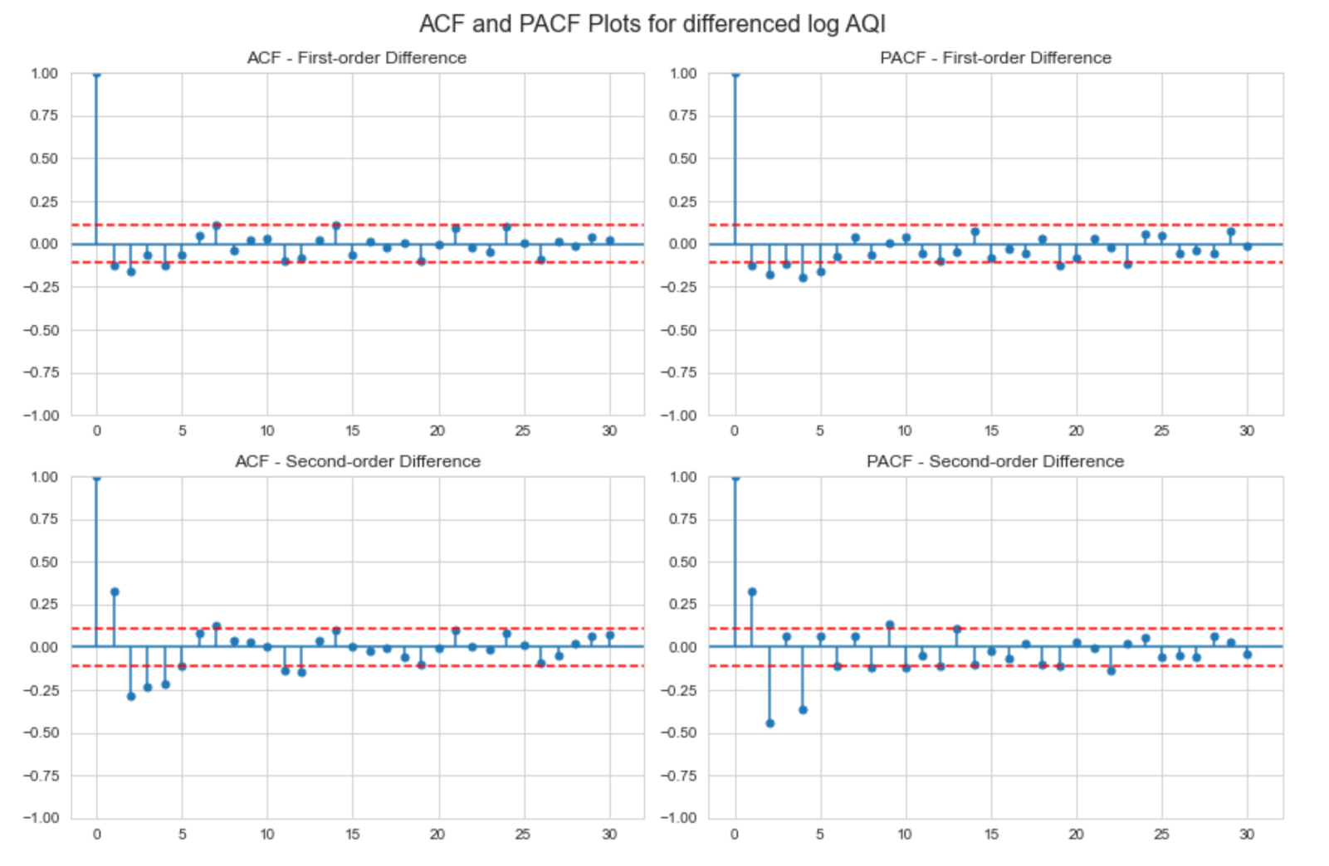

**d = 1 :** The autocorrelations for first order differenced time series are all small, demonstrating that stationarity has now been achieved.

**d = 2 :** The autocorrelations for second order differenced time series has spikes at 2, 3 and 4, showing extra correlation that has emerged because of overdifferencing.

So, we can choose d = 1 for log AQI.

**3.2- For uniform transformed series**



**ACF Plot –**

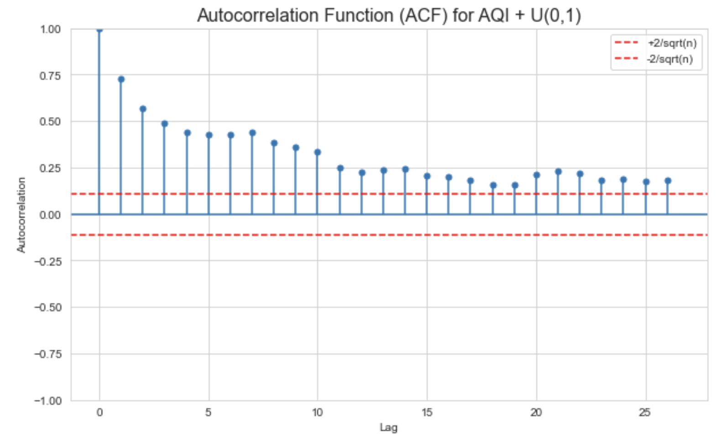

* The ACF in this case is very similar to that of log AQI, displaying a slow decay, indicating the presence of a unit root and thus non-stationarity.
* Spikes are also observed at lag 7, 14 and 21, indicating the presence of seasonality which will be examined later.

**Differencing to achieve stationarity**

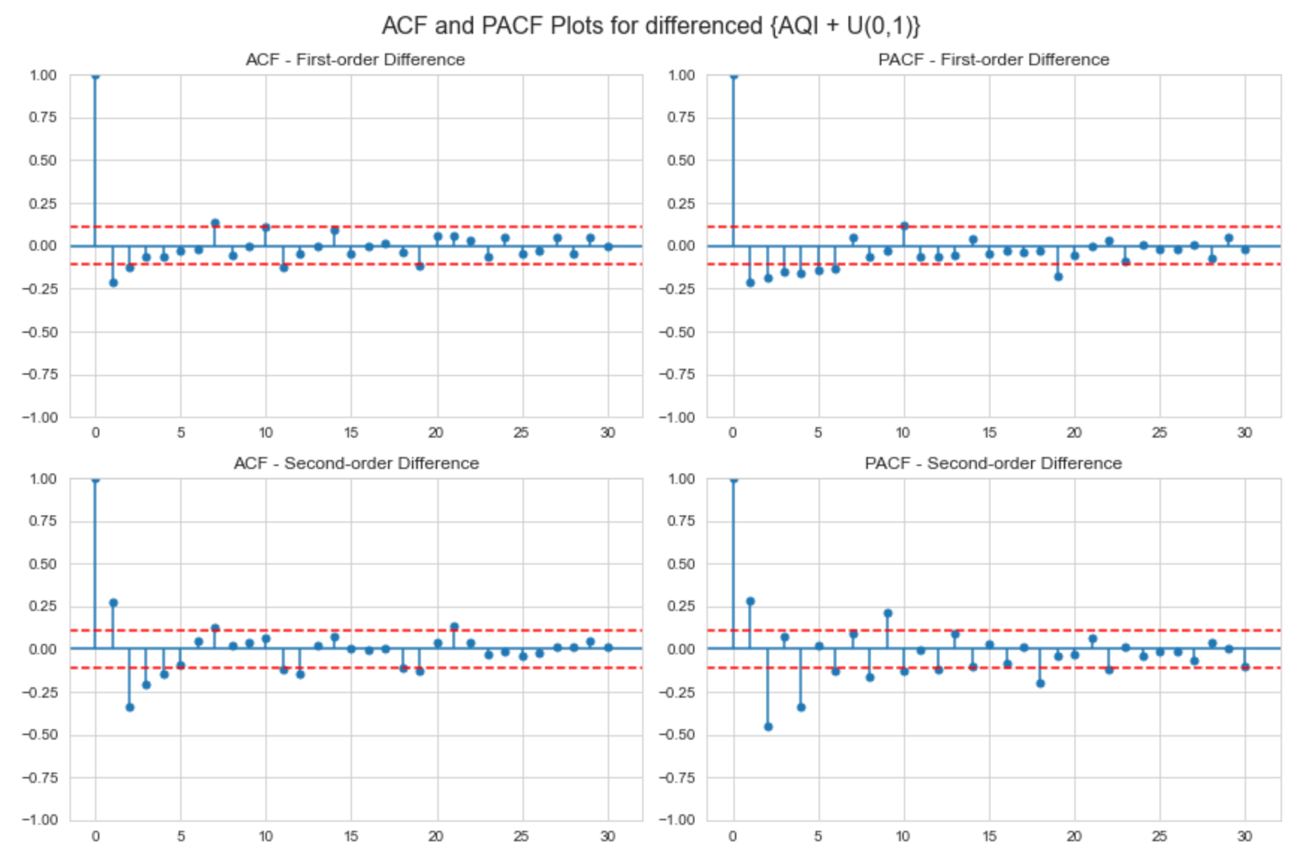

In this case of we can observe overdifferencing at d = 2. So, we will

take **d = 1** in this case also.

**4- Model Identification**

**4.1- For Log transformed series**

**4.1.1- ARIMA Models**

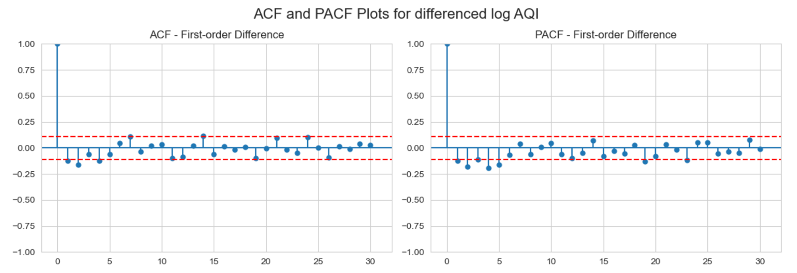

In the log transformed series we can see that

* ACF cuts of after lag 2 and PACF shows damped sine waves - ARIMA (0,1,1) and ARIMA (0,1,2)
* PACF cuts of after lag 5 and ACF shows damped sine waves - ARIMA(5,1,0).
* ACF tails of after lag 2 and PACF cuts of after lag 5 - ARIMA(5,1,2)

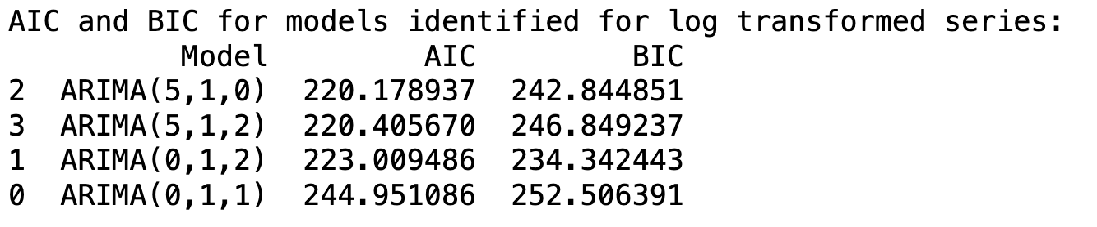

Based on AIC and BIC, ARIMA(5,1,0) and ARIMA(0,1,2) is identified as a plausible model for log transformed series.

**4.1.2- SARIMA Models**

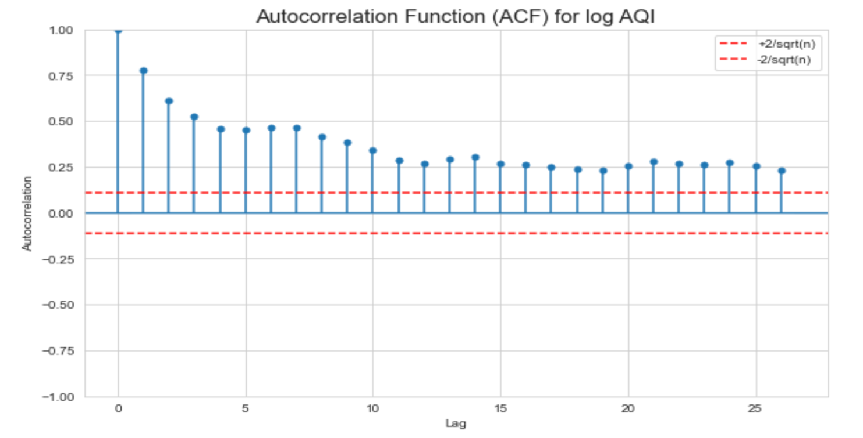

As previously noted, significant spikes at lags 7, 14, and 21 suggest a weekly seasonal pattern with a periodicity of 7 days. To address this and achieve stationarity, we will apply seasonal differencing with a periodicity of 7 days.

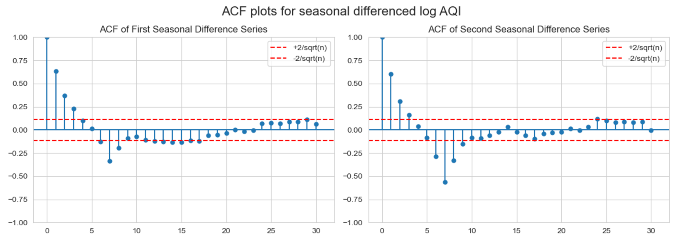

We observed an increase in spikes with second-order seasonal differencing, indicating that a first-order seasonal difference (D = 1) is more appropriate. However, the autocorrelations remained strong at lags 6, 7, and 8. To address this, we will apply normal differencing in addition to seasonal differencing to further reduce these autocorrelations.

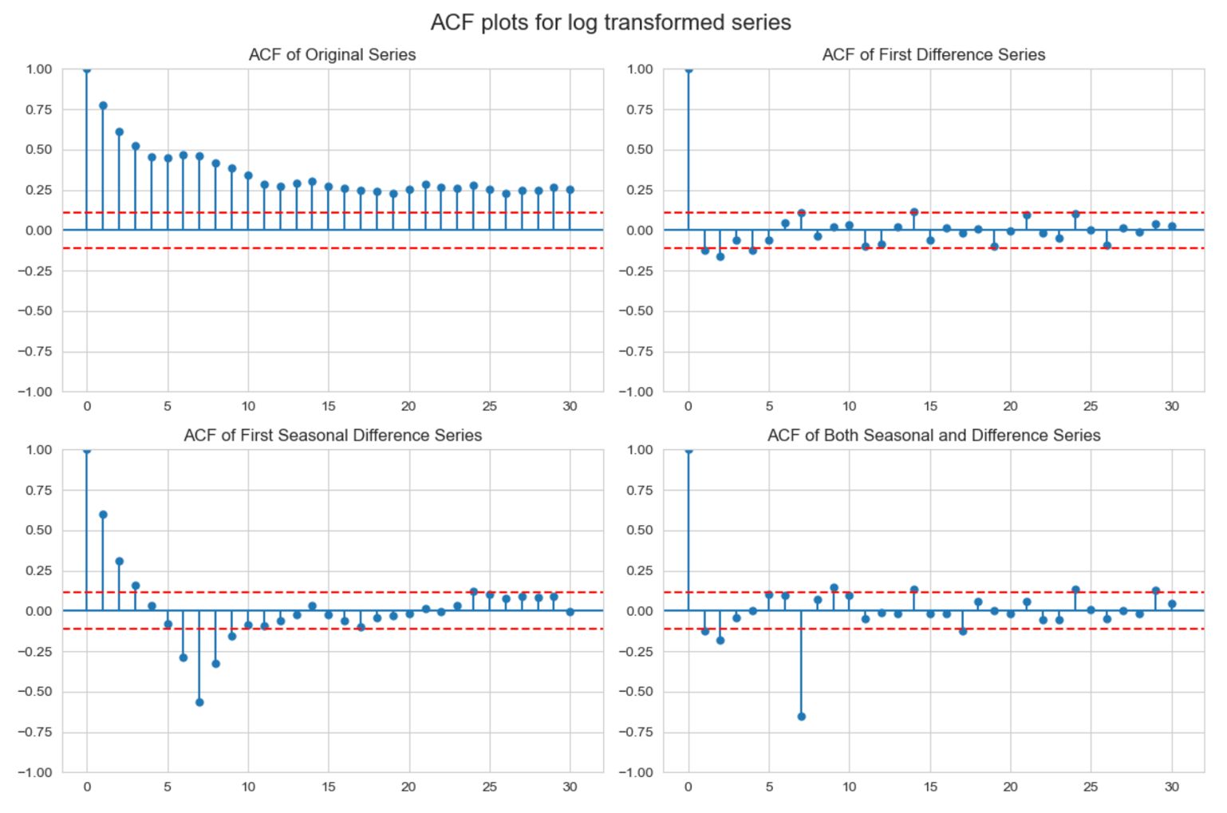

We can see that seasonal differencing along with normal differencing has markedly reduced the autocorrelations throughout.

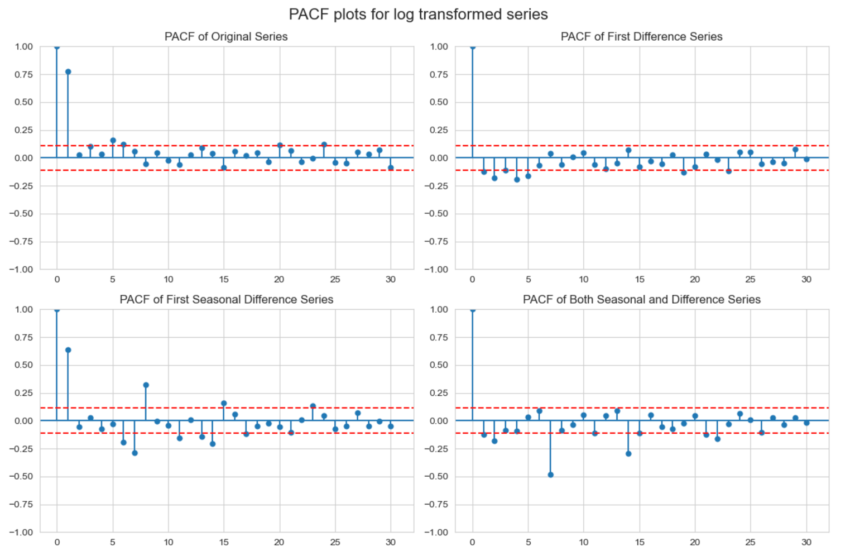

Based on the Partial Autocorrelation Function (PACF), the autocorrelation diminishes after lag 2, with noticeable spikes occurring at lags 7, 14, and 21. This suggests that the order of the autoregressive component `**p**` might be between 0 and 2, while the seasonal autoregressive component `**P**` could be in the range of 0 to 3, accounting for the observed periodicity.

The Autocorrelation Function (ACF) decreases significantly after lag 2, with a notable spike at lag 14. This observation suggests that the possible values for the moving average component **‘q’** could range from 0 to 2, while the seasonal moving average component **‘Q’** might be either 0 or 1.

Considering these potential values for **p, q, P** and **Q**, we calculated the **AIC and BIC** for a variety of SARIMA models. The top five models with the best AIC and BIC scores are listed below:

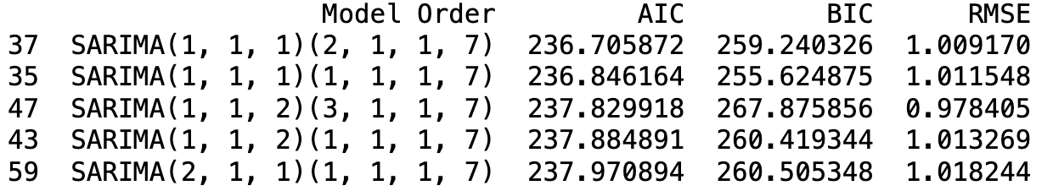

Based on AIC and BIC, plausible models are: SARIMA(1,1,1)(2,1,1) and SARIMA(1,1,1)(0,1,1). These model will diagnosed in the next chapter.

**4.2- For uniform transformed series**

**4.2.1- ARIMA Models**

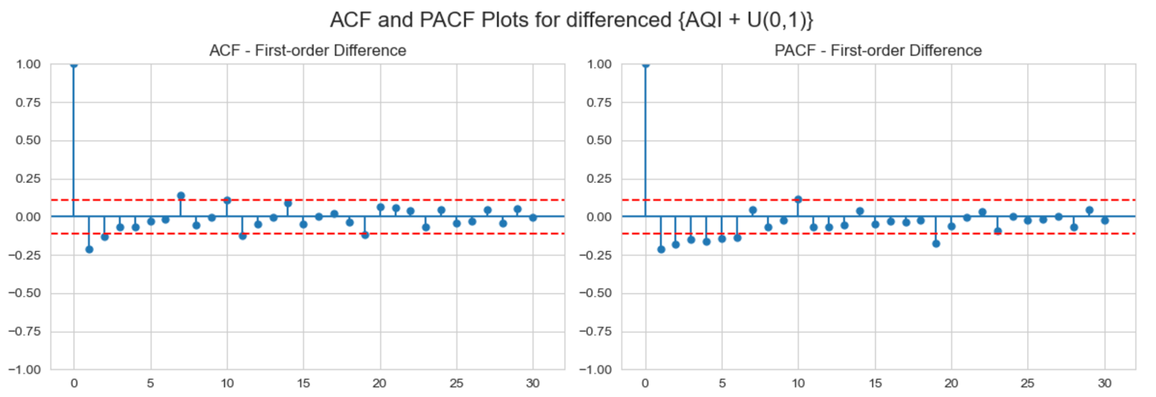

In the uniform transformed series we can see that

* ACF cuts of after lag 2 and PACF can we considered to tail off exponentially - ARIMA (0,1,1) and ARIMA (0,1,2)
* PACF cuts of after lag 5 or 6 and ACF is a mixture of exponential and damped sine waves. - ARIMA(5,1,0) and ARIMA (6,1,0).
* ACF decays exponentially from lag 1 and PACF also decays after lag 1 - ARIMA(1,1,1)

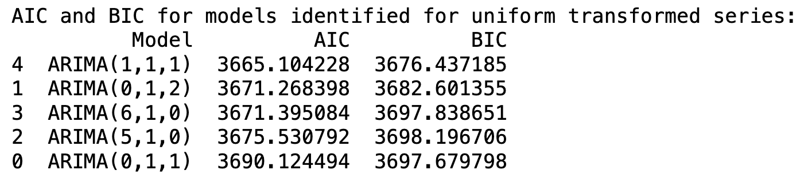

Based on AIC and BIC, ARIMA(1,1,1) is identified as a plausible model for uniform transformed series.

**4.2.2- SARIMA Models**

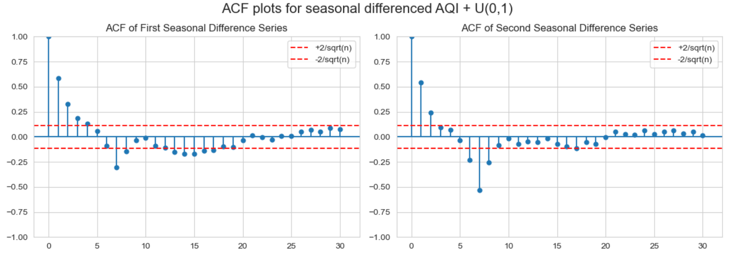

We observed an increase in spikes with second-order seasonal differencing, indicating that a first-order seasonal difference (D = 1) is more appropriate.

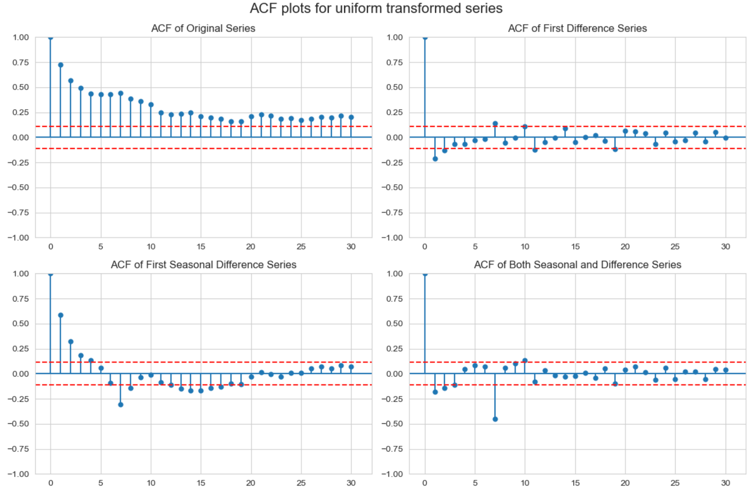

We can see that seasonal differencing along with normal differencing has markedly reduced the autocorrelations throughout.

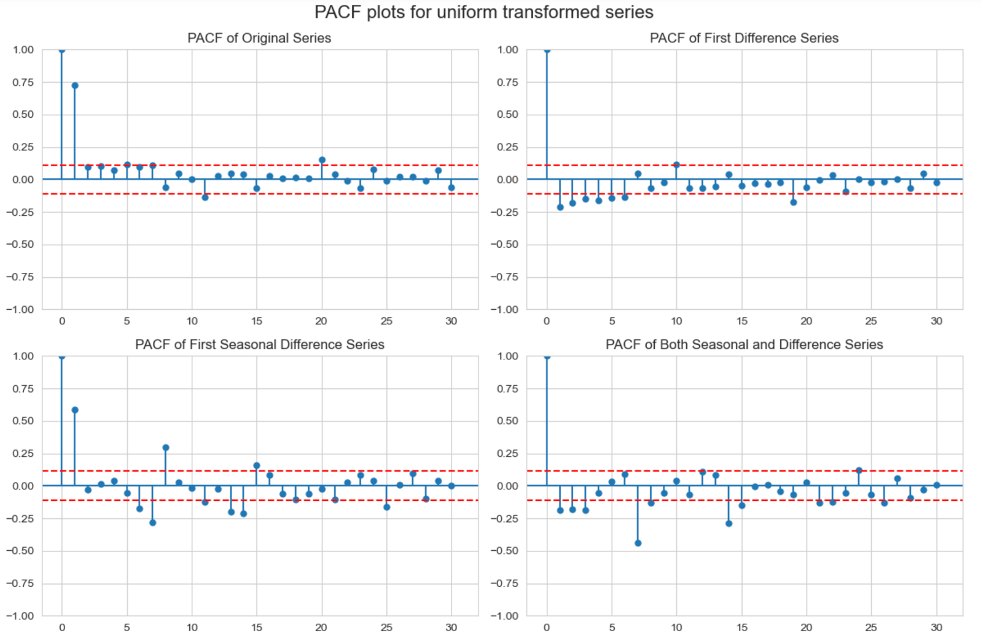

Based on the Partial Autocorrelation Function (PACF), the autocorrelation diminishes after lag 3, with noticeable spikes occurring at lags 7 and 14. This suggests that the order of the autoregressive component `**p**` might be between 0 and 3, while the seasonal autoregressive component `**P**` could be in the range of 0 to 2, accounting for the observed periodicity.

The Autocorrelation Function (ACF) decreases significantly after lag 2, with a notable spike at lag 14. This observation suggests that the possible values for the moving average component **‘q’** could range from 0 to 2, while the seasonal moving average component **‘Q’** might be either 0 or 1.

Considering these potential values for **p, q, P** and **Q**, we calculated the **AIC and BIC** for a variety of SARIMA models. The top five models with the best AIC and BIC scores are listed below:

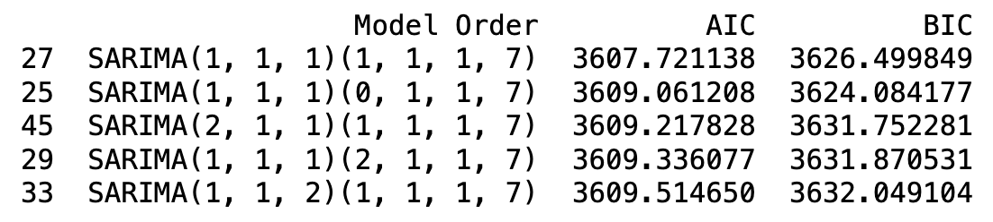

Based on AIC and BIC, plausible models are: SARIMA(1,1,1)(1,1,1) and SARIMA(1,1,1)(0,1,1). These model will diagnosed in the next chapter.

**5- Model Diagnostics**

**5.1- For Log transformed series**

**IMA(0, 1, 2)**

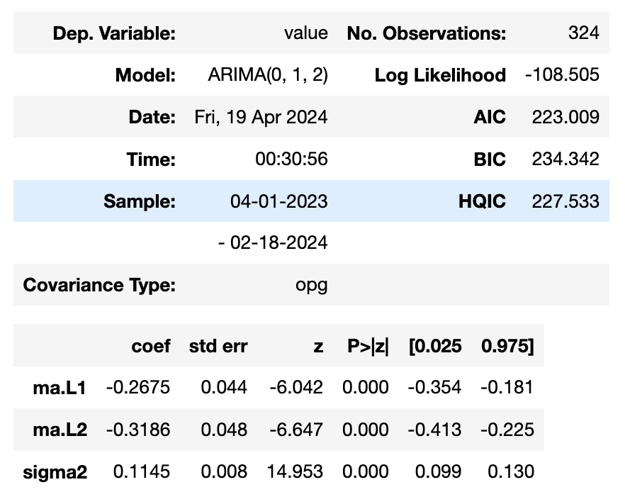

We can see that all the coefficients are coming out to be significant.

**Residual Diagnostics**

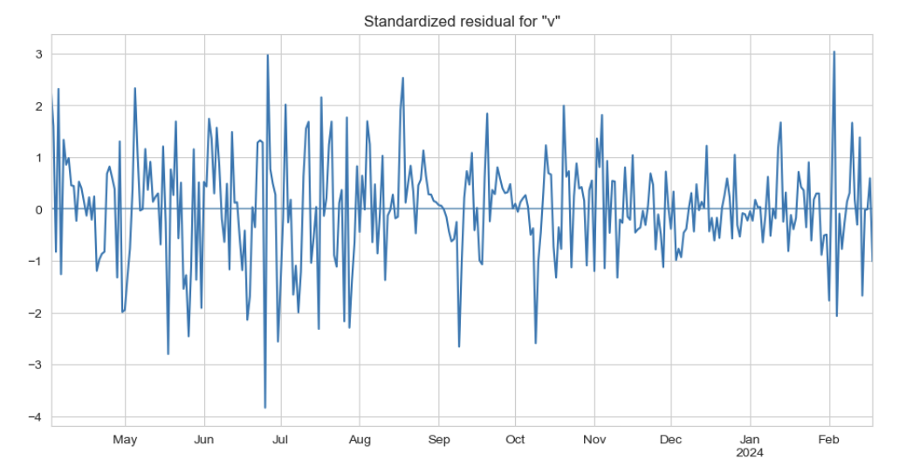

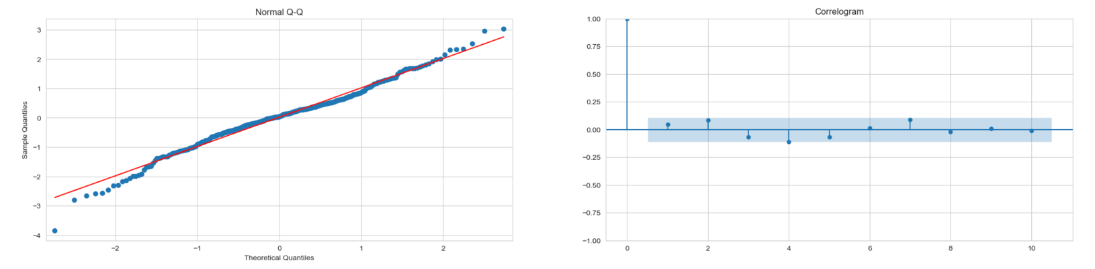

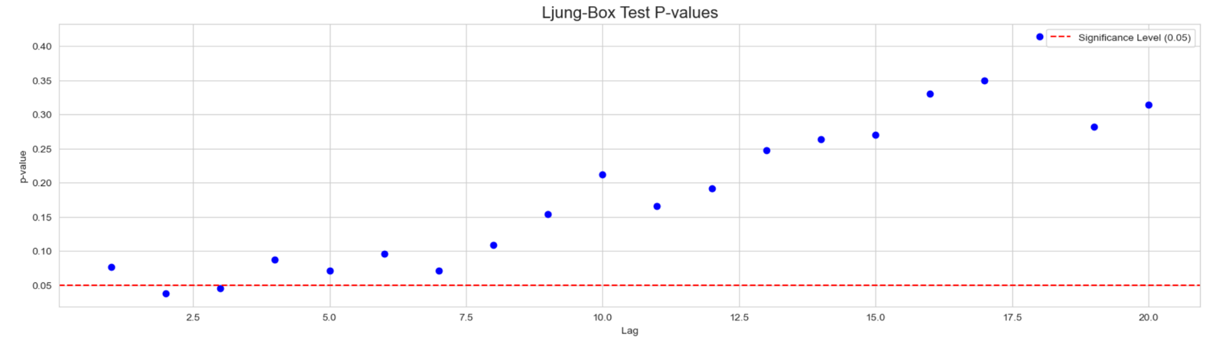While most of the individual autocorrelations fall within the two-standard-error bounds, some values including 𝑟2(𝑎̂), 𝑟4(𝑎̂) and 𝑟7(𝑎̂), are close to these bounds. There is a suspicion of some lack of fit. This is confirmed by examining the 𝑝-values of the Ljung and Box test shown in the bottom graph. We note that some of the 𝑝-values at smaller lags are below or near the 5% level indicating some lack of fit.

**ARIMA(5, 1, 0)**

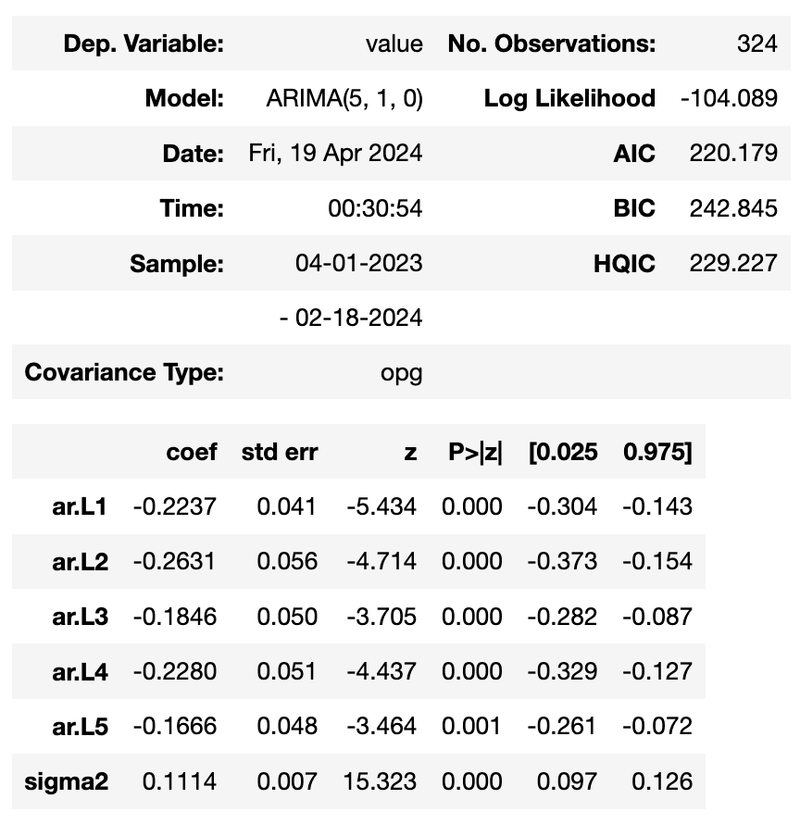

We can see that all the coefficients are coming out to be significant.

**Residual Diagnostics:**

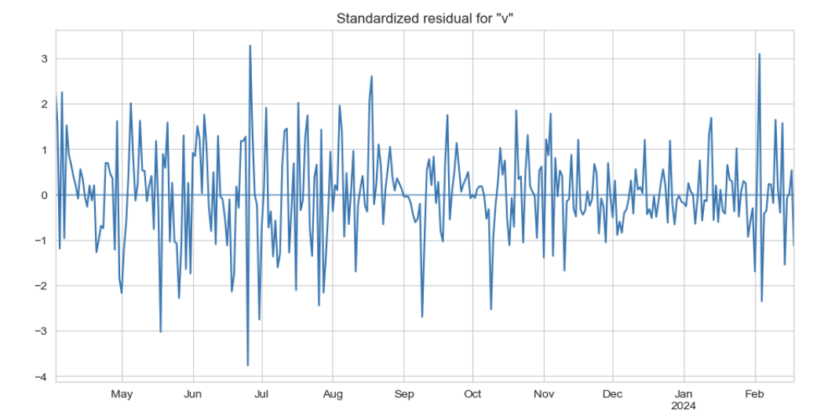

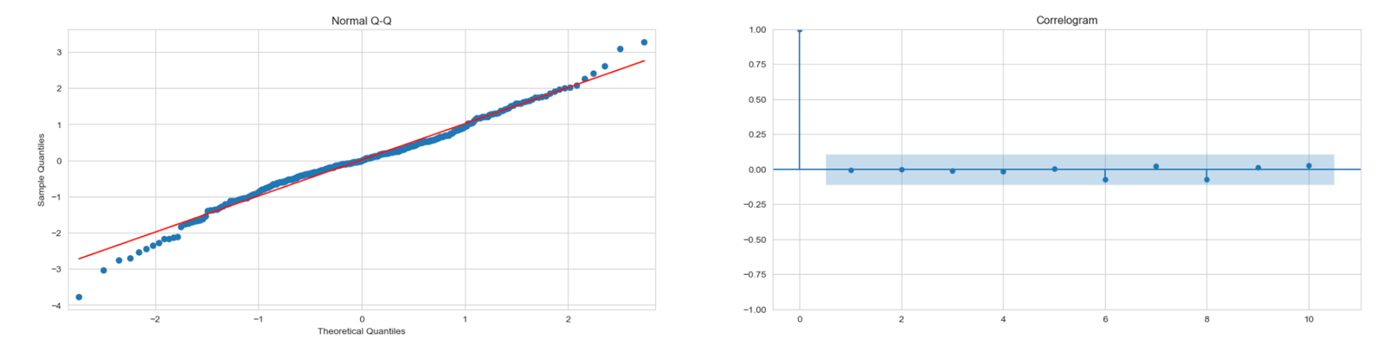

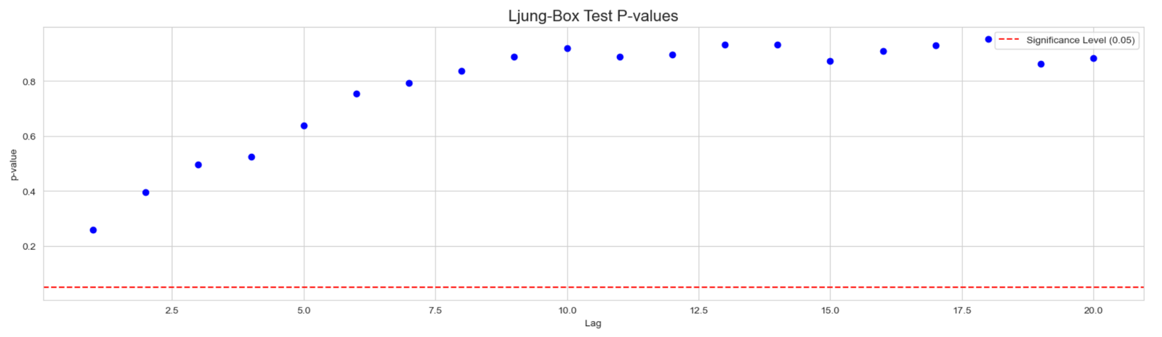

The graph of the residual autocorrelation function shows no large values for this model. This is also reflected in the 𝑝-values of the Ljung and Box statistic shown at the bottom of the graph. These diagnostic checks show a clear improvement over the IMA(0, 1, 2) model examined above. The graph of the standardized residuals and the normal Q--Q plot reveal that outliers are present, however.

**SARIMA(1, 1, 1)(2, 1, 1)**

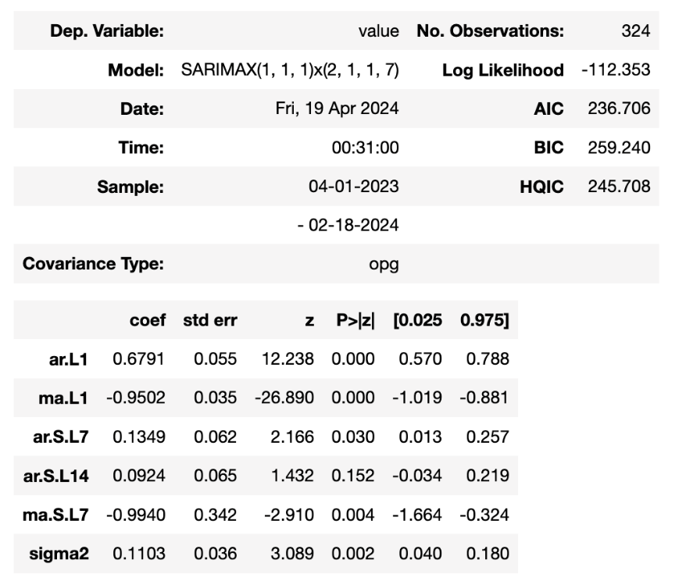

We can see that all the coefficients are coming not out to be significant. Model inadequacy can be suspected.

**Residual Diagnostics:**

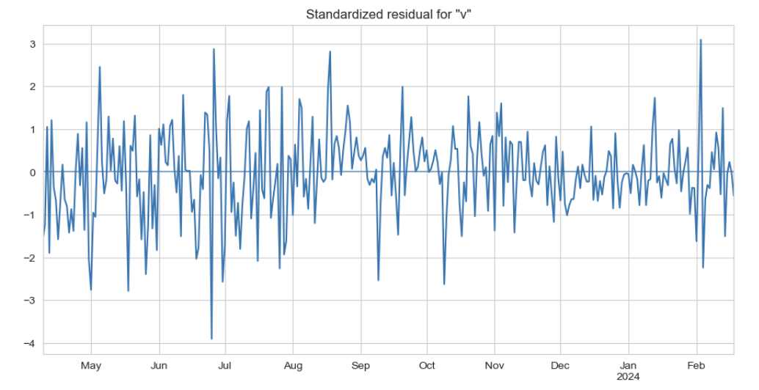

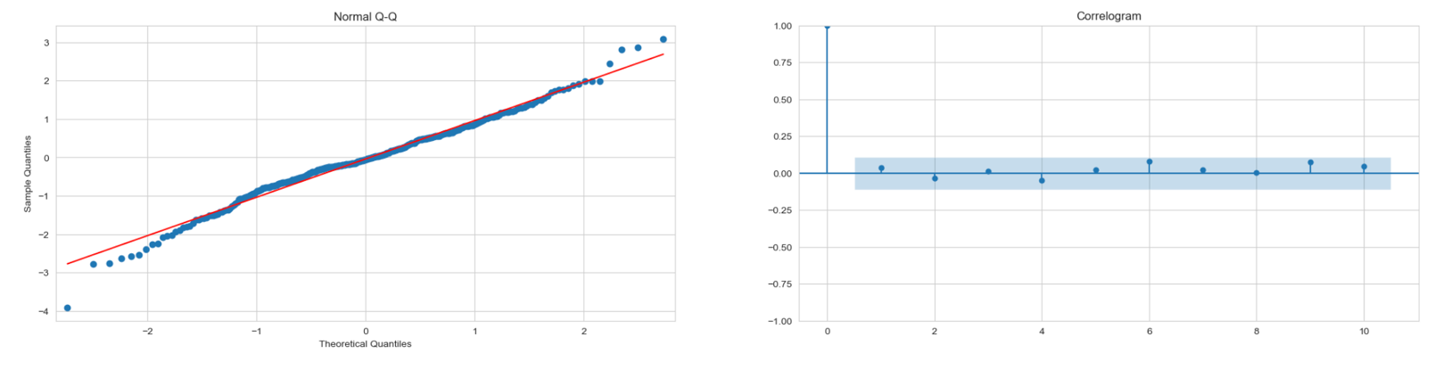

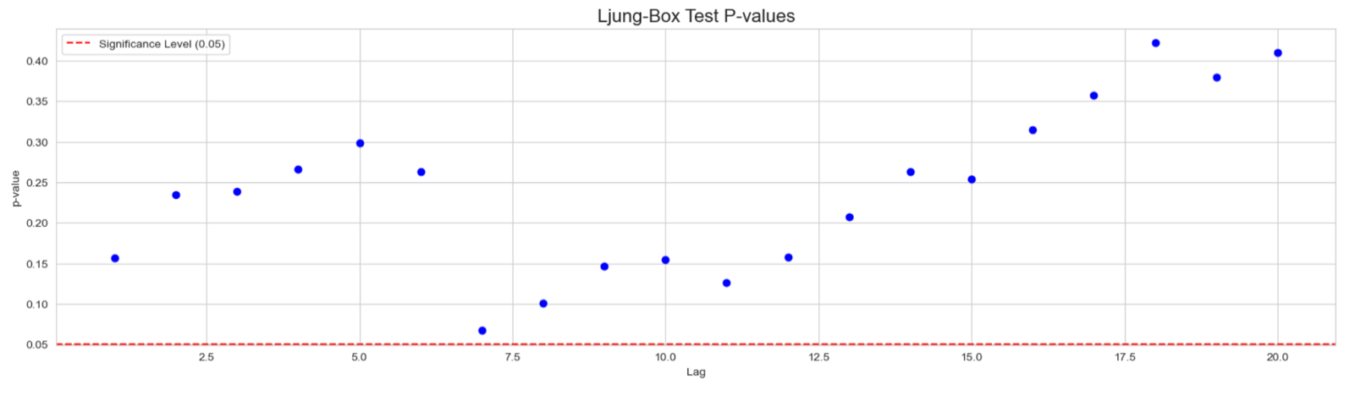

The graph of the residual autocorrelation function shows no large values for this model. This is also reflected in the 𝑝-values of the Ljung and Box statistic shown at the bottom of the graph. P-value at lag 7 is very close to 5% level.

**SARIMA(1, 1, 1)(0, 1, 1)**

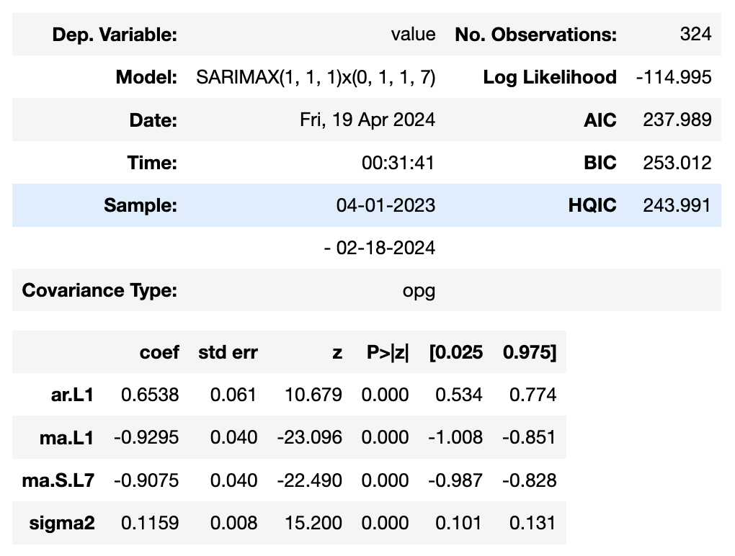

We can see that all the coefficients are coming out to be significant.

**Residual Diagnostics:**

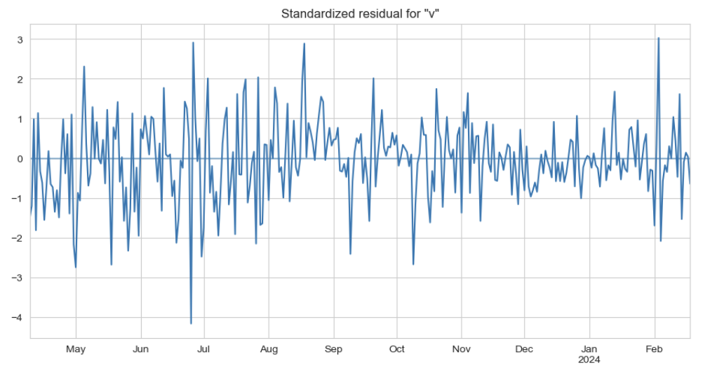

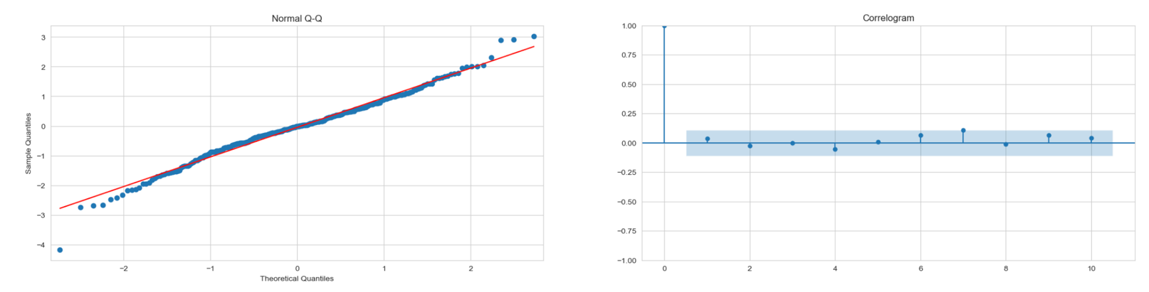

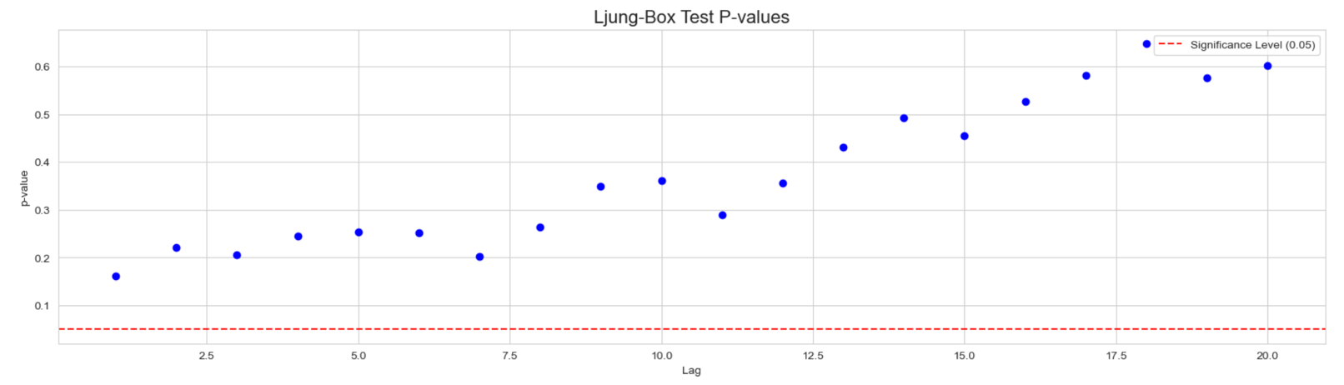

The graph of the residual autocorrelation function shows no large values for this model. This is also reflected in the 𝑝-values of the Ljung and Box statistic shown at the bottom of the graph. These diagnostic checks show a clear improvement over the SARIMA(1, 1, 1)(2, 1, 1) model examined above. The graph of the standardized residuals and the normal Q--Q plot reveal that outliers are present, however.

**5.2- For uniform transformed series**

**ARIMA(1, 1, 1)**

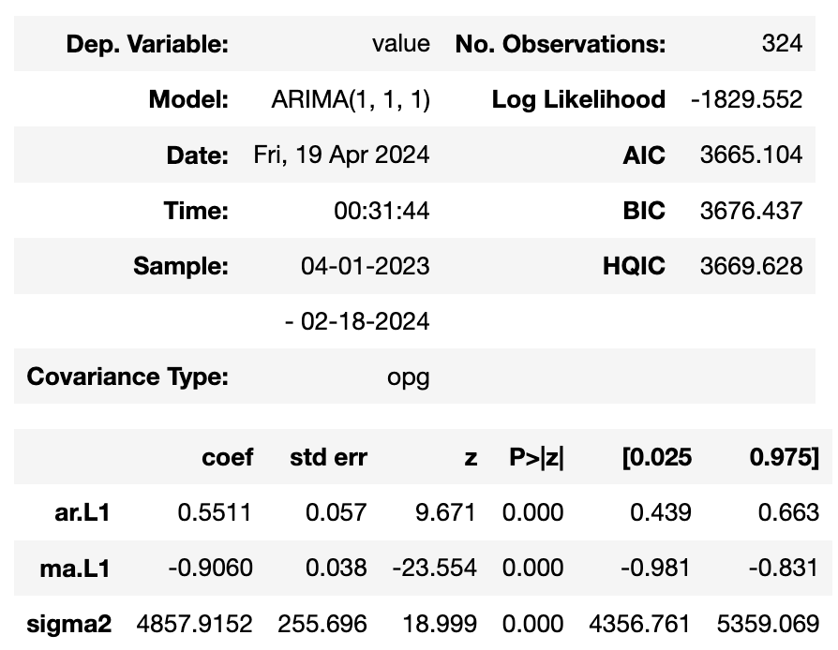

We can see that all the coefficients are coming out to be significant.

**Residual Diagnostics:**

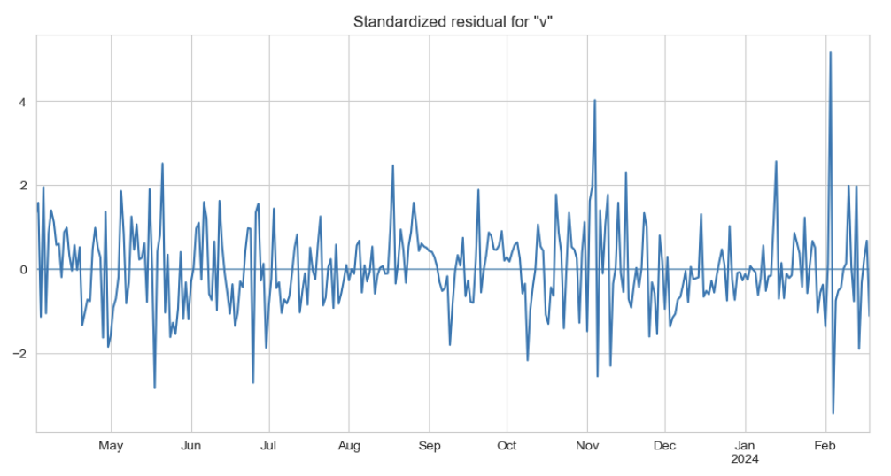

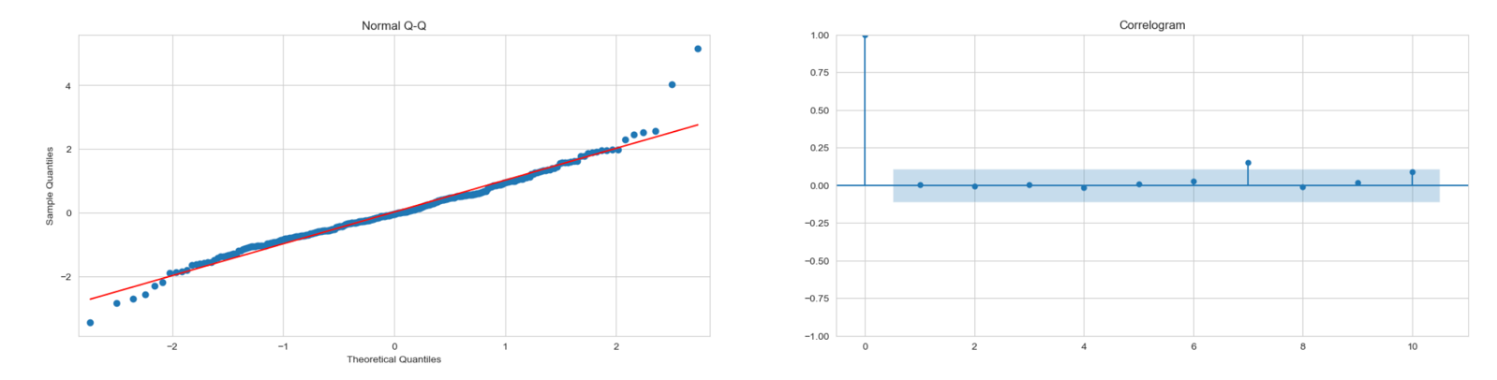

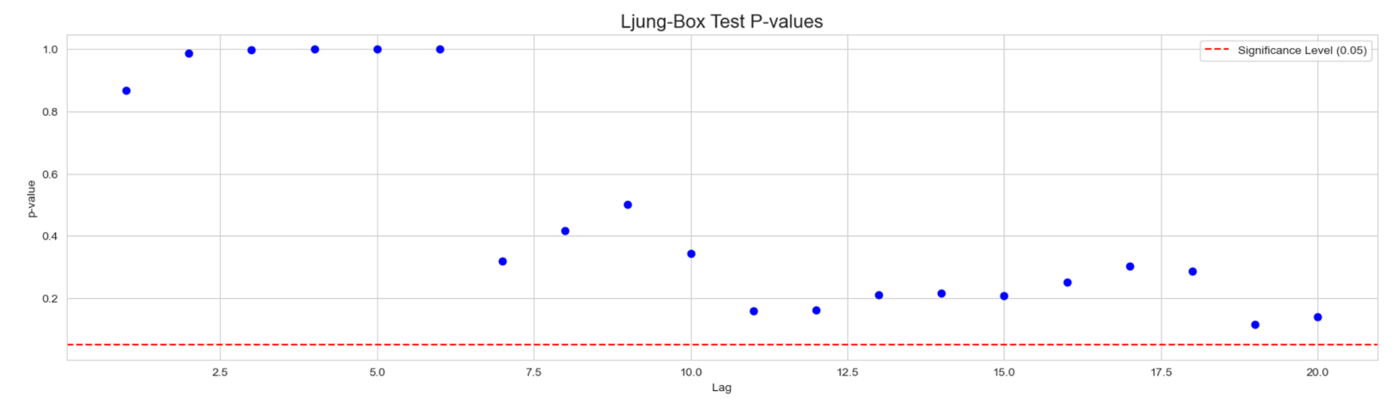

The graph of the residual autocorrelation function shows a large spike at lag 7 for this model. This is also reflected in the 𝑝-values of the Ljung and Box statistic shown at the bottom of the graph which are very low for large lags. The normal Q--Q plot reveal serious departure from normality.

**SARIMA(1, 1, 1)(0, 1, 1)**

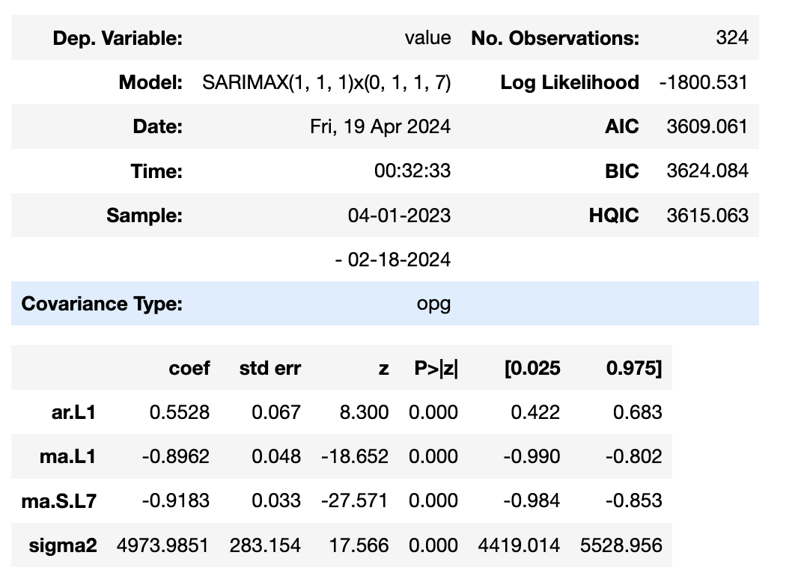

We can see that all the coefficients are coming out to be significant.

**Residual Diagnostics:**

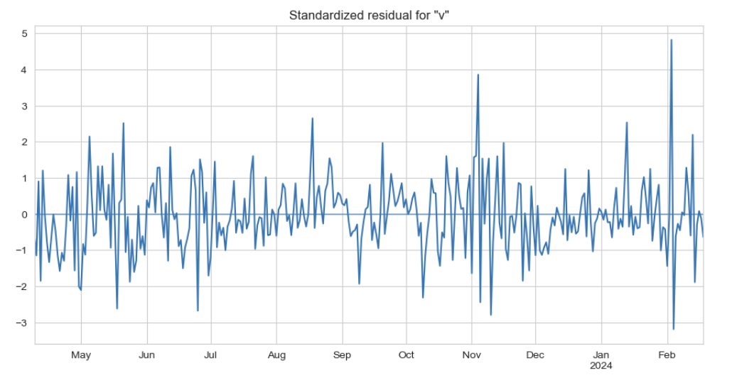

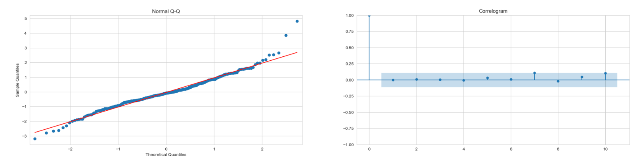

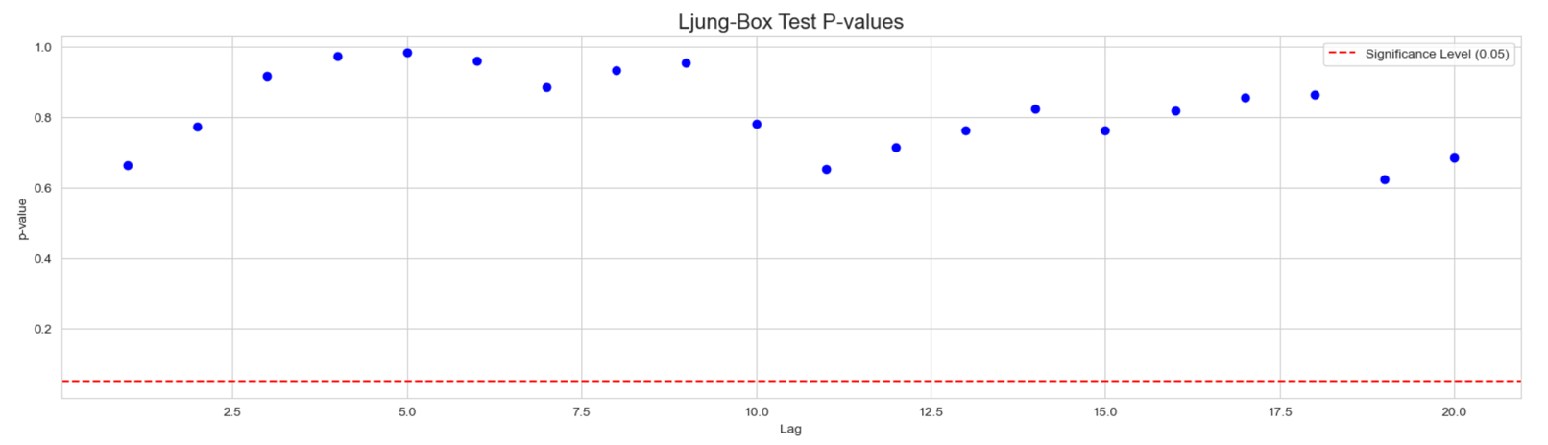

In this model also graph of the residual autocorrelation function shows a large spike at lag 7 for this model. But the 𝑝-values of the Ljung and Box statistic shown at the bottom of the graph are well above the 5% level. The normal Q--Q plot reveal serious departure from normality (on the right side).

**SARIMA(1, 1, 1)(1, 1, 1)**

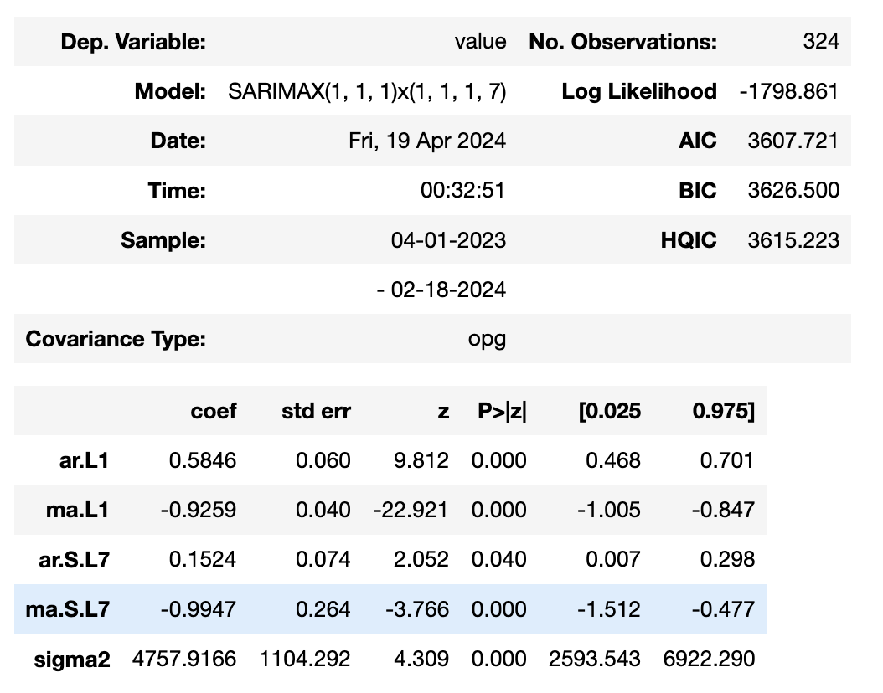

We can see that all the coefficients are coming out to be significant.

**Residual Diagnostics:**

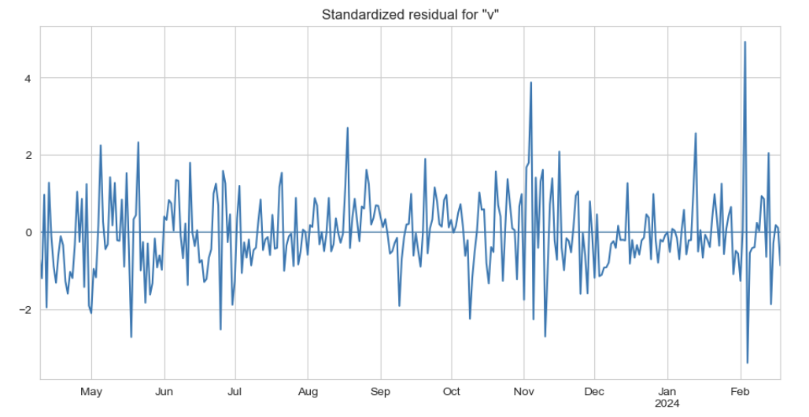

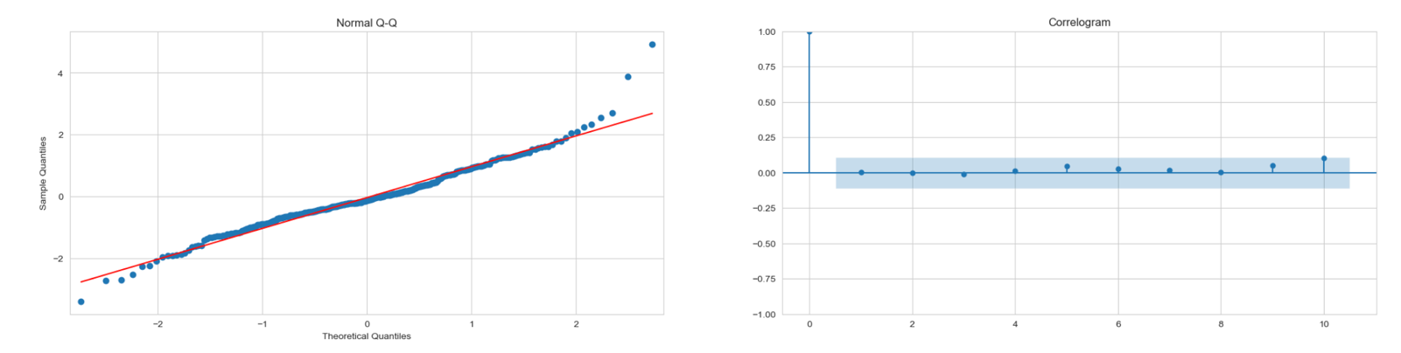

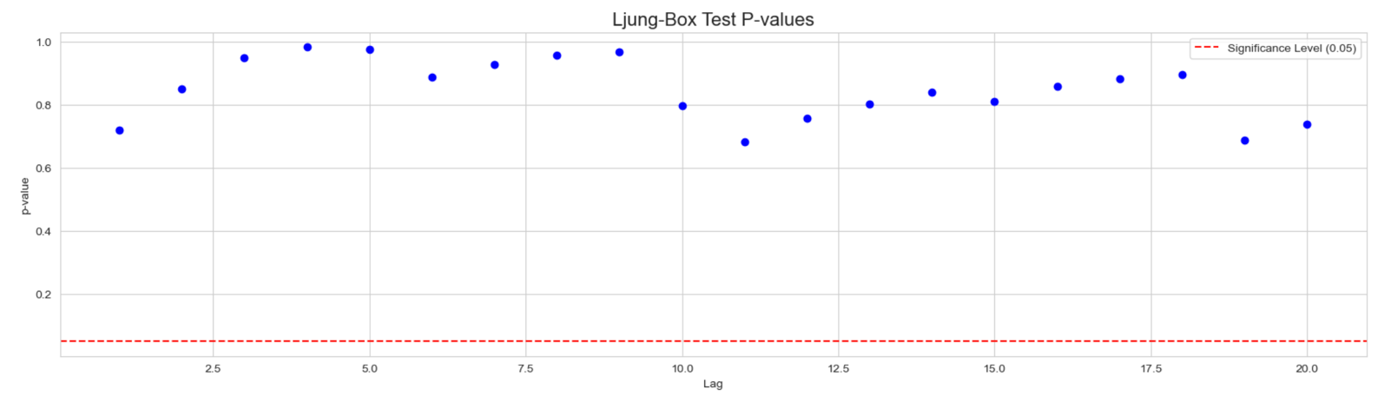

The graph of the residual autocorrelation function shows no large values for this model. This is also reflected in the 𝑝-values of the Ljung and Box statistic shown at the bottom of the graph. These diagnostic checks show a clear improvement over the SARIMA(1, 1, 1)(0, 1, 1) model examined above. The graph of the standardized residuals and the normal Q--Q plot reveal that outliers are present, however.

**6- Forecasting**

**6.1- For Log transformed series**

**IMA(0, 1, 2)**

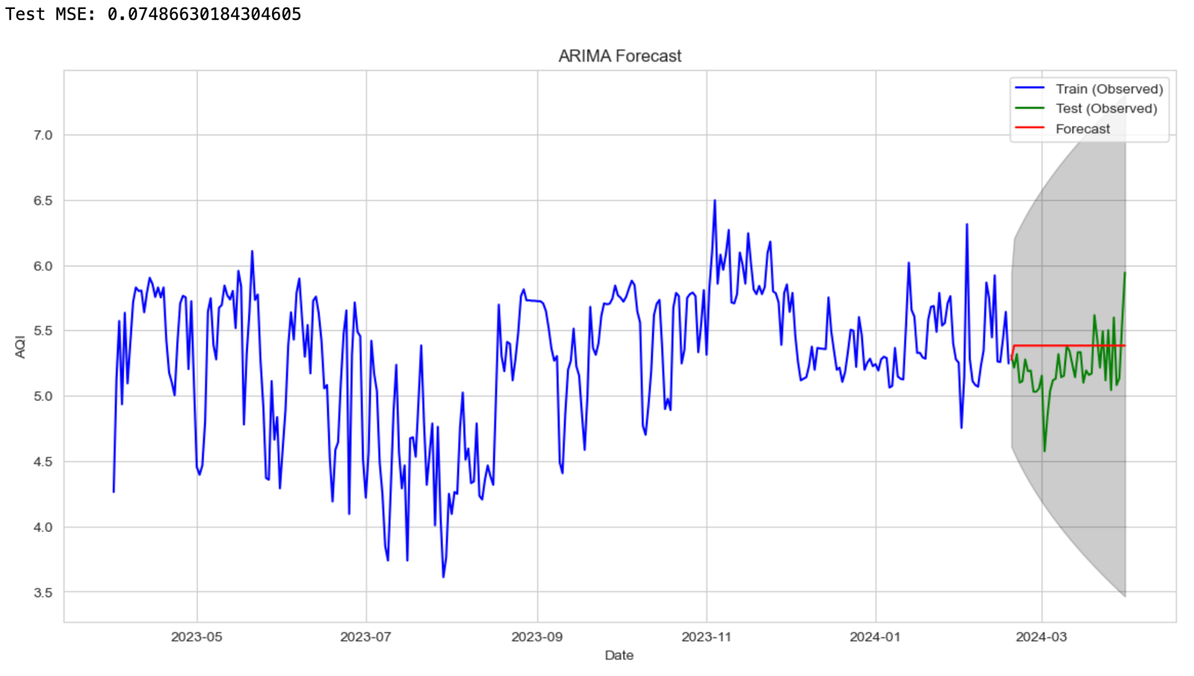

**ARIMA(5, 1, 0)**

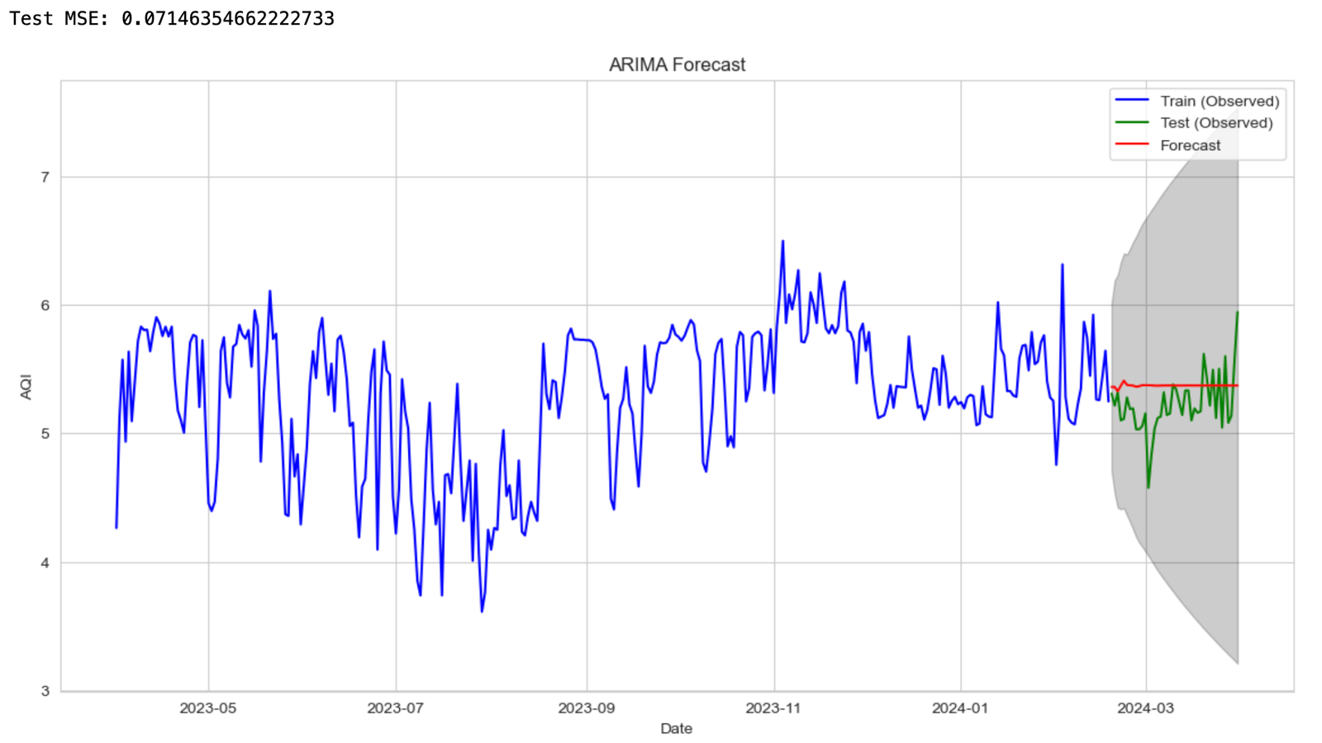

**SARIMA(1, 1, 1)(2, 1, 1)**

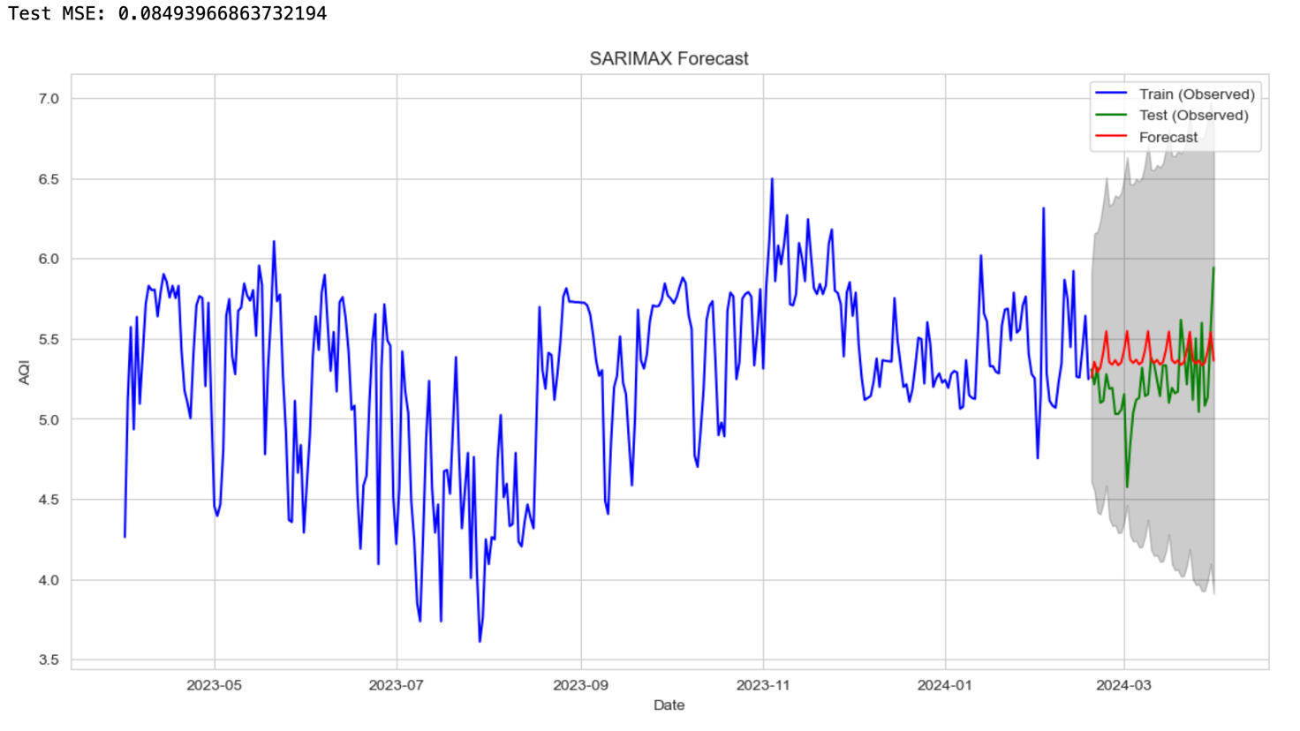

**SARIMA(1, 1, 1)(0, 1, 1)**

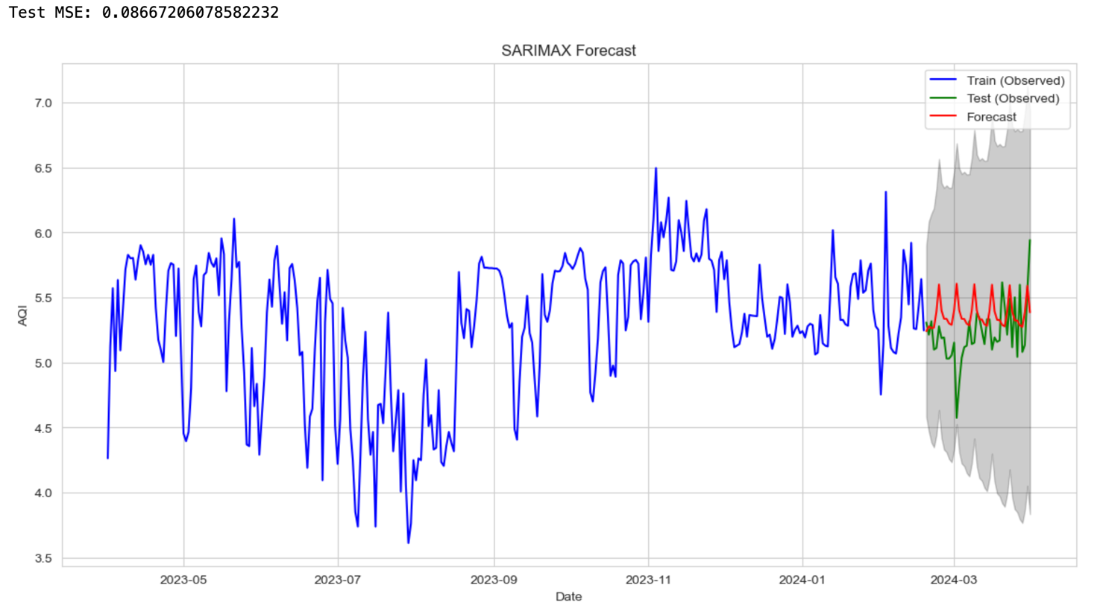

**Summary:**

|  |  |  |  |
| --- | --- | --- | --- |
| Model | AIC | BIC | MSE (Test) |
| IMA(0, 1, 2) | 223.009 | 234.342 | 0.07487 |
| ARIMA(5, 1, 0) | 220.179 | 242.845 | 0.07146 |
| SARIMA(1, 1, 1)(2,1,1) | 236.706 | 259.240 | 0.08494 |
| SARIMA(1, 1, 1)(0,1,1) | 237.989 | 253.012 | 0.08667 |

**6.2- For uniform transformed series**

**ARIMA(1, 1, 1)**

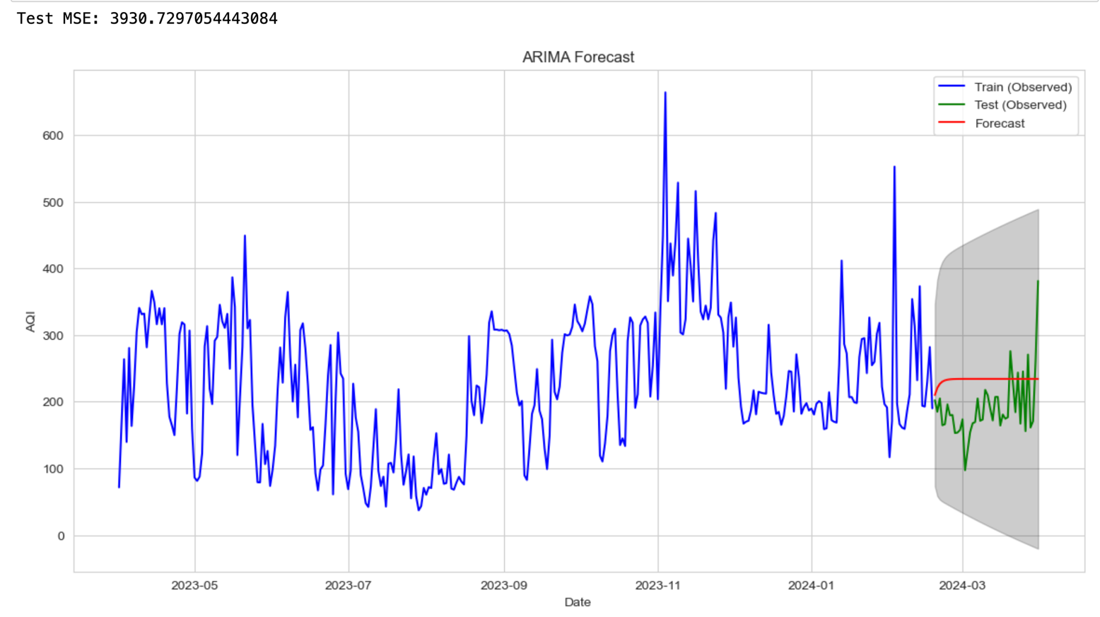

**SARIMA(1, 1, 1)(0, 1, 1)**

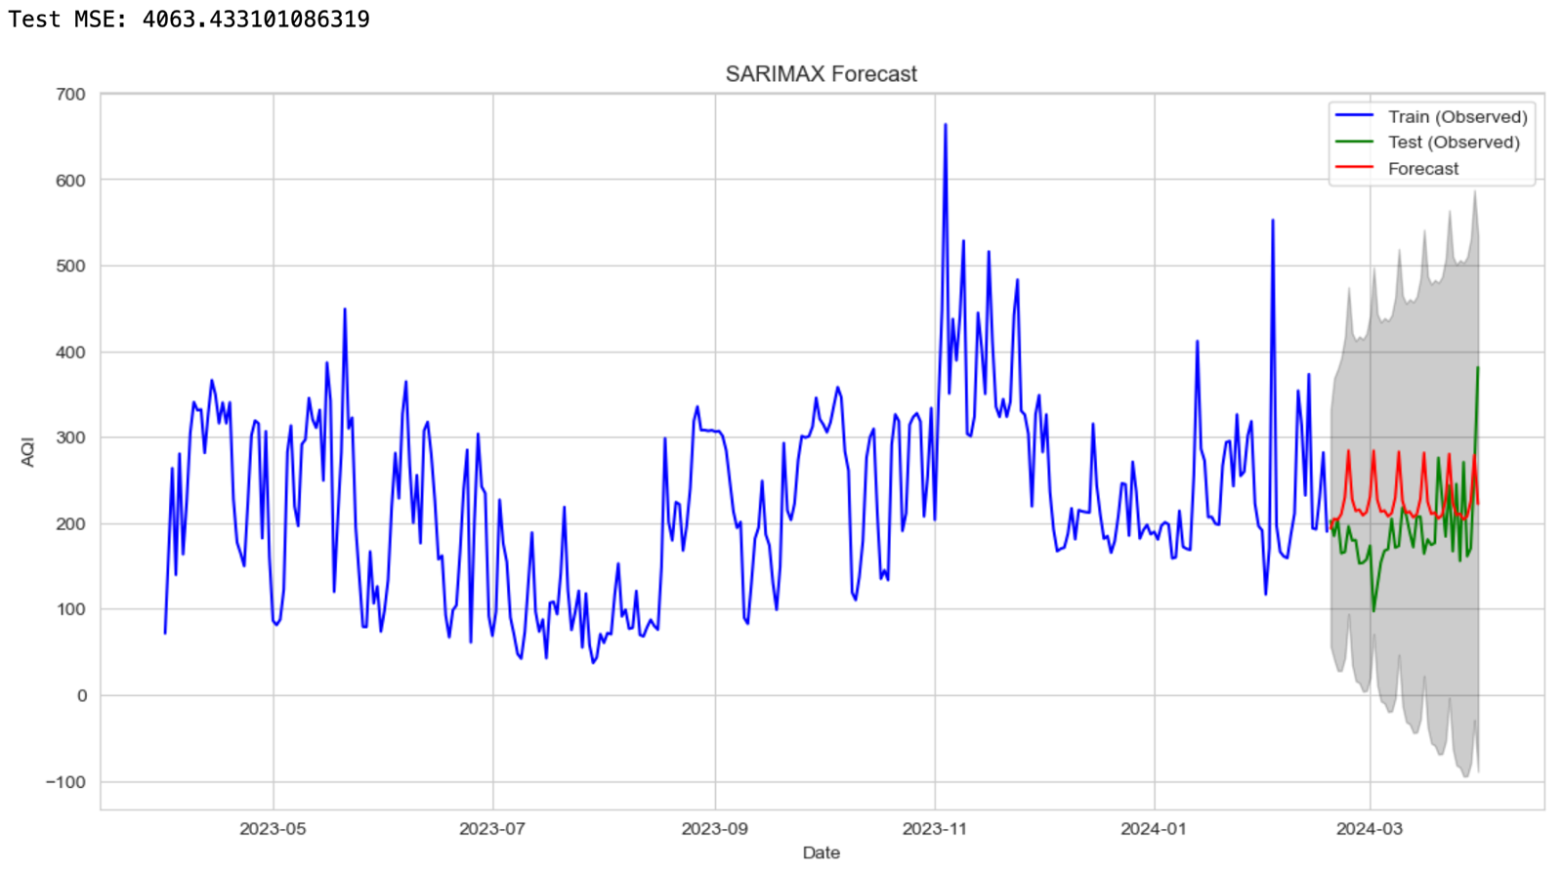

**SARIMA(1, 1, 1)(1, 1, 1)**

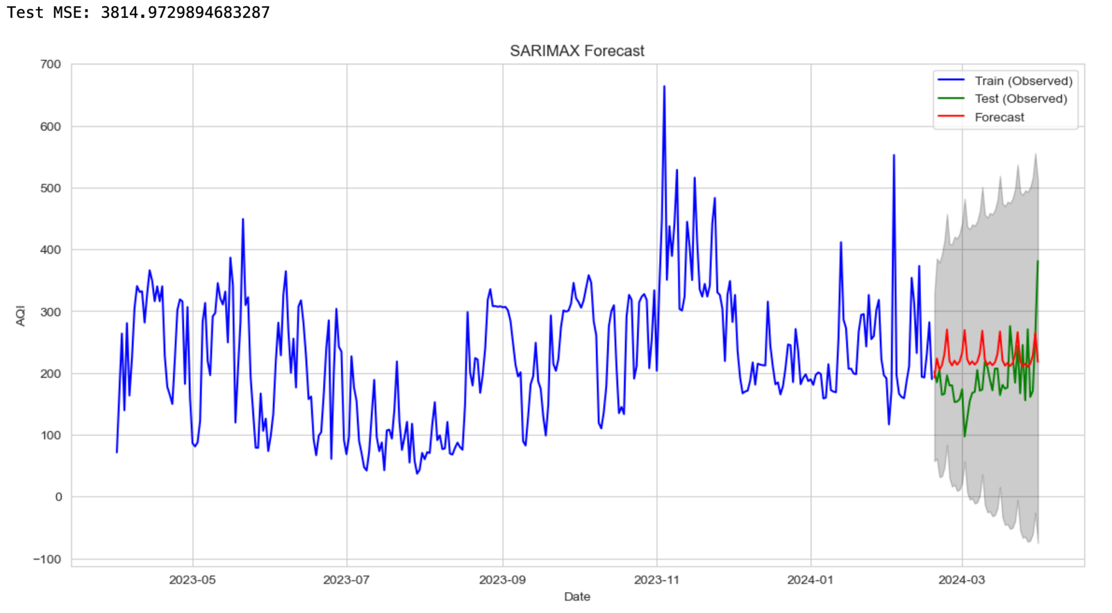

**Summary:**

|  |  |  |  |
| --- | --- | --- | --- |
| Model | AIC | BIC | MSE (Test) |
| ARIMA(5, 1, 0) | 3665.104 | 3676.437 | 3930.7297 |
| SARIMA(1, 1, 1)(0,1,1) | 3609.061 | 3264.084 | 4063.4331 |
| SARIMA(1, 1, 1)(1,1,1) | 3607.721 | 3626.500 | 3814.9730 |